 | Department of Computer Science  Faculty of Computing  UNIVERSITI TEKNOLOGI MALAYSIA

SUBJECT NAME: | COMPUTER ORGANIZATION AND ARCHITECTURE
SUBJECT CODE: | SECR 1033
SEMESTER: | 2 – 2023/2024
LAB TITLE: | Lab 2: Arithmetic Equations & Operations
STUDENT INFO : | Execute the lab in group of two.  Student 1 Student 2  No. 1, 3, 5 No 2, 4, 6  Name 1: Dayang Farah Farzana binti Abang Idham  Metric No: A23CS0071  Link for Video Demo: https://drive.google.com/file/d/1r0f5IUBrCNz1Zl46yTLeTU_8caA8jLWQ/view?usp=drivesdk  Name 2: Farra Nurzahin binti Zaharil Anuar  Metric No: A23CS0079  Link for Video Demo: https://drive.google.com/file/d/1EILLV15Fh1P9ud88-0JPNiWpucjvb9pm/view?usp=drivesdk
SUBMISSION DATE & ITEMS: | Duration of submission :-  2 weeks  Submission items in elearning:-  1. Lab 2 exercise sheet/file (in .pdf), with the links for demo video 5 - 10min, on the cover page.  2. The assembly programs (in .asm).

MARKS:
________

Arithmetic Equation Coding in Assembly Language

Q1. Execute the program below. Determine output of the program by inspecting the content of the related registers.
- Fill in Table 1 with the content of each register or variable on every LINE, in Hexadecimal (as per the output). Please complete the comments for every LINE.
- Paste the screenshot of all registers’ content after each LINE is executed.

INCLUDE Irvine32.inc
.data
var1 word 1
var2 word 9

.code
main PROC
mov ax, var1 ; LINE1
mov bx, var2 ; LINE2
xchg ax, bx ; LINE3
mov var1, ax ; LINE4
mov var2, bx ; LINE5
call DumpRegs
exit
main ENDP
END main

Answer Q1

- Fill (Write) in the contents for the related register in each line:

Table 1
LINE 1 | AX = 0001h  var1 = 0001h | Move the value of var1 (1d) into register AX
LINE 2 | BX = 0009h  var2 = 0009h | Move the value of var2 (9d) into register BX
LINE 3 | AX = 0009h  BX = 0001h | Exchange value in AX to BX and vice versa
LINE 4 | AX = 0009h  var1 = 0009h | Move the value in AX (9d) into var1
LINE 5 | BX = 0001h  var2 = 0001h | Move the value in BX (1d) into var2

b) Paste here screenshot of all registers’ content after each LINE is executed:

LINE1:

LINE2:

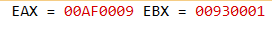
LINE3:

LINE4:

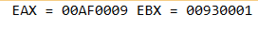
LINE5:

Q2. Execute the program below. Determine output of the program by inspecting the content of the related registers and watches.
- Fill in Table 2 with the content of each register or variable on every LINE, in Hexadecimal (as per the output). Please complete the comments for every LINE.
- Paste the screenshot of all registers’ content after each LINE is executed.

Arithmetic expression: Rval = (-Xval + (Yval – Zval)) + 1

include irvine32.inc

.data
Rval DWORD ?
Xval DWORD 26
Yval DWORD 30
Zval DWORD 40

.code
main proc
mov eax,Xval ; LINE1
neg eax ; LINE2
mov ebx,Yval ; LINE3
sub ebx,Zval ; LINE4
add eax,ebx ; LINE5
inc eax ; LINE6
mov Rval,eax ; LINE7
exit
main endp
end main

Answer Q2

- Fill (Write) in the contents for the related register in each line:

Table 2
LINE 1 | EAX = 0000001Ah  Xval = 0000001Ah | Move the value of Xval (26d) into register EAX
LINE 2 | EAX = FFFFFFE6h | Negate value in EAX
LINE 3 | EBX = 0000001Eh  Yval = 0000001Eh | Move the value of Yval (30d) into register EBX
LINE 4 | EBX = FFFFFFF6h  Zval = 00000028h | Subtract value of Zval (40d) from EBX
LINE 5 | EAX = FFFFFFDCh  EBX = FFFFFFF6h | Add the value in EBX to EAX
LINE 6 | EAX = FFFFFFDDh | Increment the value in EAX by 1
LINE 7 | EAX = FFFFFFDDh  Rval = FFFFFFDDh | Move the value in EAX into Rval (-35d)

b) Paste here screenshot of all registers’ content after each LINE is executed:

LINE1:
LINE2:

LINE3:

LINE4:

LINE5:

LINE6:

LINE7:

Q3. Execute the program below. Determine output of the program by inspecting the content of the related registers.
- Fill in Table 3 with the content of each register or variable on every LINE, in Hexadecimal (as per the output). Please complete the comments for every LINE.
- Paste the screenshot of all registers’ content after each LINE is executed.

Arithmetic expression: var4 = [(var1 * var2) + var3] - 1

include irvine32.inc

.data
var1 DWORD 5
var2 DWORD 10
var3 DWORD 20
var4 DWORD ?

.code
main proc
mov eax, var1 ; LINE1
mul var2 ; LINE2
add eax, var3 ; LINE3
dec eax ; LINE4
exit
main endp
end main

Answer Q3

- Fill (Write) in the contents for the related register in each line:

Table 3
LINE 1 | EAX = 00000005h  var1 = 00000005h | Move the value of var1 (5d) into register EAX
LINE 2 | EAX= 00000032h  var2 = 0000000Ah | Multiply the value in EAX with var2 (10d)
LINE 3 | EAX = 00000046h  var3 = 00000014h | Add the value of var3 (20d) into EAX
LINE 4 | EAX = 00000045h  var4 = undefined | Decrement the value in EAX by 1 and the value of var4 is undefined

b) Paste here screenshot of all registers’ content after each LINE is executed:

LINE1:

LINE2:

LINE3:

LINE4:

Q4. Execute the program below. Determine output of the program by inspecting the content of the related registers.
- Fill in Table 4 with the content of each register or variable on every LINE, in Hexadecimal (as per the output). Please complete the comments for every LINE.
- Paste the screenshot of all registers’ content after each LINE is executed.

Arithmetic expression: var4 = (var1 * 5) / (var2 – 3)

include irvine32.inc
.data
var1 WORD 40
var2 WORD 10
var4 WORD ?
.code
main proc
mov ax,var1 ; LINE1
mov bx,5 ; LINE2
mul bx ; LINE3
mov bx,var2 ; LINE4
sub bx,3 ; LINE5
div bx ; LINE6
mov var4,ax ; LINE7
exit
main endp
end main

Answer Q4

- Fill (Write) in the contents for the related register in each line:

Table 3
LINE 1 | AX = 0028h  var1 = 0028h | Move the value of var1 (40d) into register AX
LINE 2 | BX = 0005h | Move the value of 5d into BX
LINE 3 | AX = 00C8h  BX = 0005h | Multiply the value in BX into AX
LINE 4 | BX = 000Ah  var2 = 000Ah | Move the value of var2 (10d) into BX
LINE 5 | BX = 0007h | Subtract the value in BX by 3d
LINE 6 | AX = 001Ch  BX = 0007h  DX = 0004h | Divide value in AX with BX and store in AX. The remainder (4d) store into DX.
LINE 7 | AX = 001Ch  var4 = 001Ch | Move value in AX into var4

b) Paste here screenshot of all registers’ content after each LINE is executed:

LINE1:

LINE2:

LINE3:

LINE4:
LINE5:

LINE6:
LINE7:

Short Notes for MUL CX and DIV BL:

MUL CX
- MUL always uses AX (or its extended versions EAX or RAX) as the implicit destination register.
- The operand size determines the size of the result:
- Byte-sized operand: Result in AX
- Word-sized operand: Result in DX:AX
- Doubleword-sized operand (32-bit mode): Result in EDX:EAX
- Quadword-sized operand (64-bit mode): Result in RDX:RAX
- The upper half of the result (DX or EDX or RDX) holds any overflow bits.
- The Carry Flag (CF) is set if the upper half of the product is non-zero.

DIV BL

- DIV always uses the DX:AX or EDX:EAX pair as the implicit dividend register.
- The divisor is specified as the operand of the DIV instruction.
- The quotient is stored in AX (for 16-bit division) or EAX (for 32-bit division).
- The remainder is stored in DX.
- Clear DX (or EDX for 32-bit division) before division to ensure a correct 16-bit or 32-bit dividend.
- If the divisor is 0, a division error occurs.
- The Overflow Flag (OF) is set if the quotient is too large to fit in the destination register.
________________________________________________

Q5. Given the following instructions as is Code Snippet 1.

- Write a full program to execute the Code Snippet 1.
- What are the contents of the related registers after Code Snippet 1 is executed? Paste the screenshot of DumpReg.

; Code Snippet 1 (MUL CX)

MOV DX,0 ; Clear DX
MOV AX,1000h ; Load 1000h into AX
MOV CX, 25h ; Load 25h into CX
MUL CX ; Multiply AX by CX, storing the result in DX:AX

Answer Q5

- Screenshot of full program (.asm) :

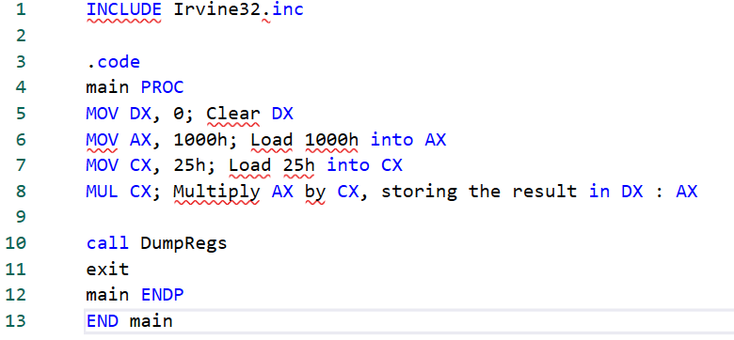

- Paste here the screenshot of the final registers’ content (DumpReg):

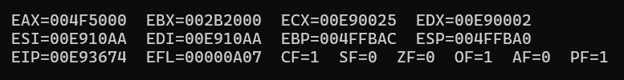

Q6. Given the following instructions as is Code Snippet 2.

- Write a full program to execute the Code Snippet 2.
- What are the contents of the related registers after Code Snippet 2 is executed? Paste the screenshot of DumpReg.

; Code Snippet 2 (DIV BL)
MOV DX, 0 ; Clear DX to form the 16-bit dividend in DX:AX
MOV AX, 803h ; Load the dividend (8003h) into AX
MOV BL, 10h ; Load the divisor (10h) into BL
DIV BL ; Divide DX:AX by BL, whereby AX=quotient & DX=remainder

Answer Q6

- Screenshot of full program (.asm) :

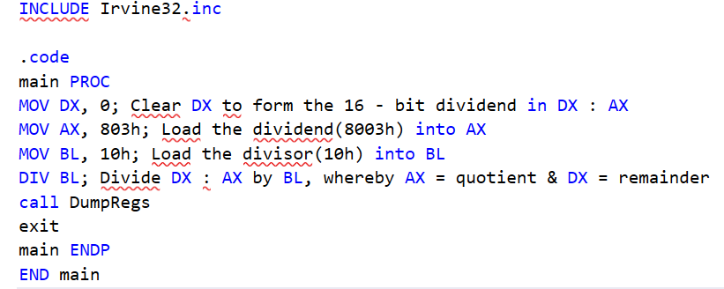

- Paste here the screenshot of the final registers’ content (DumpReg):

